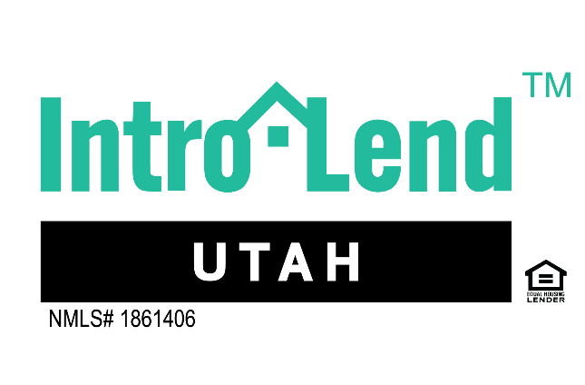


Pre-approval for__________________________

The monthly house payment you want to be around is $______________. This would be a purchase price of $________________.

I am doing a _____________________Loan with a down payment of $_________________.

The MAX that I can go on a home purchase is $_______________________.

3 Things ____________________ Expects from IntroLend Utah while doing their home loan?
1.
2.
3.
3 things IntroLend Utah will do to make sure we WOW your home buying experience.
- Update you each Tuesday on how your file is coming along (your realtor will get the same call)
- Within 48 hours of gather all your documents we will have a needs list out of what we are missing. This will help us to hit our goal of getting you into underwriting 15 days before settlement.
- Return phone calls and texts with in 2 hour of receiving them.
Referrals

