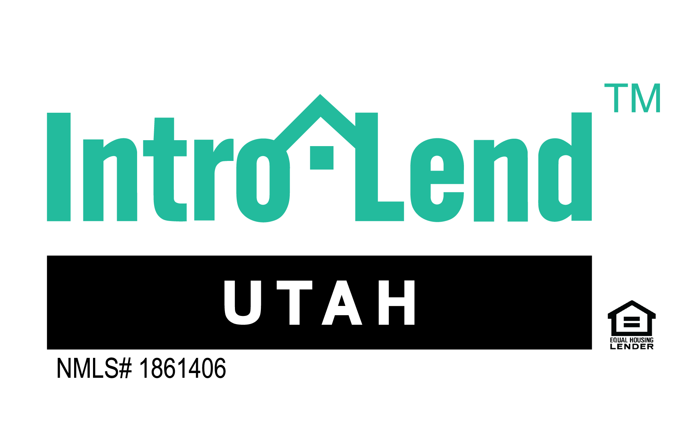

Date:

**Proposal for _______________**

_______________ I am honored by the opportunity to work with you. I have known of your reputation in the real estate community and I am excited to get the chance to do business with you.

Your main concerns/ primary objectives you shared were:

* _______________
* _______________
* _______________

What I will specifically do to help you:

* ______________________
* ______________________
* ______________________

What I specifically want in return is:

* ______________________

By signing below, we will create informal agreement to mutually help each other’s businesses. Either party can cancel this agreement at any time with no notice. We both fully intend to make this a win, win relationship by working together to create a synergistic relationship!

Thank You!

_______________ _________________

Client Mortgage Consultant

Loan Consultant

NMLS# _________